Creating Spring boot application which has a feature to allow user to input employee details storing the same data into to the database ( Here i have used in-memory provided by spring boot as i was facing issue setting up oracle database because of the memory issue in my laptop )

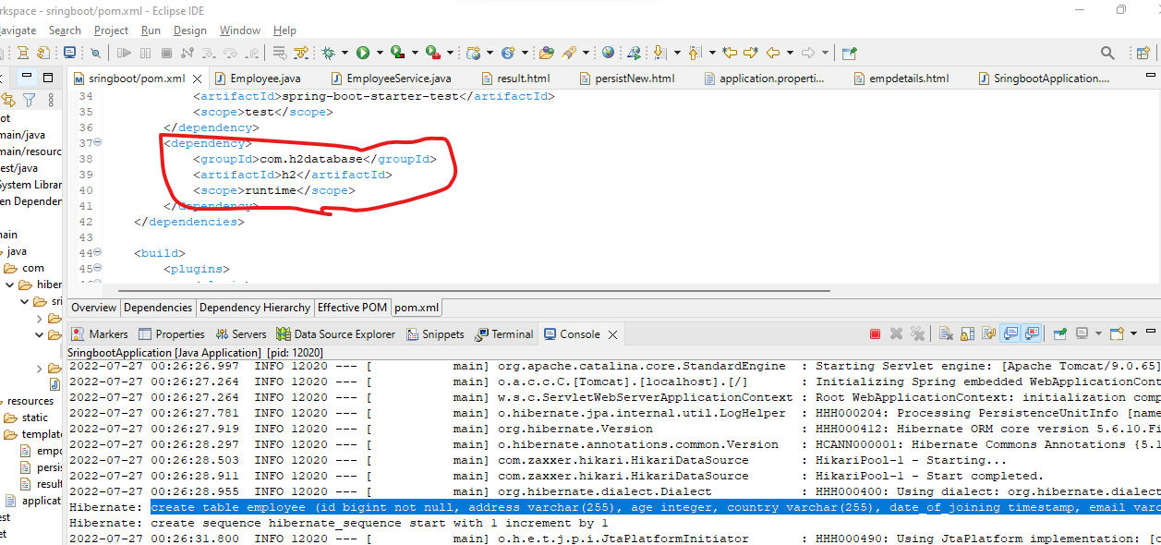

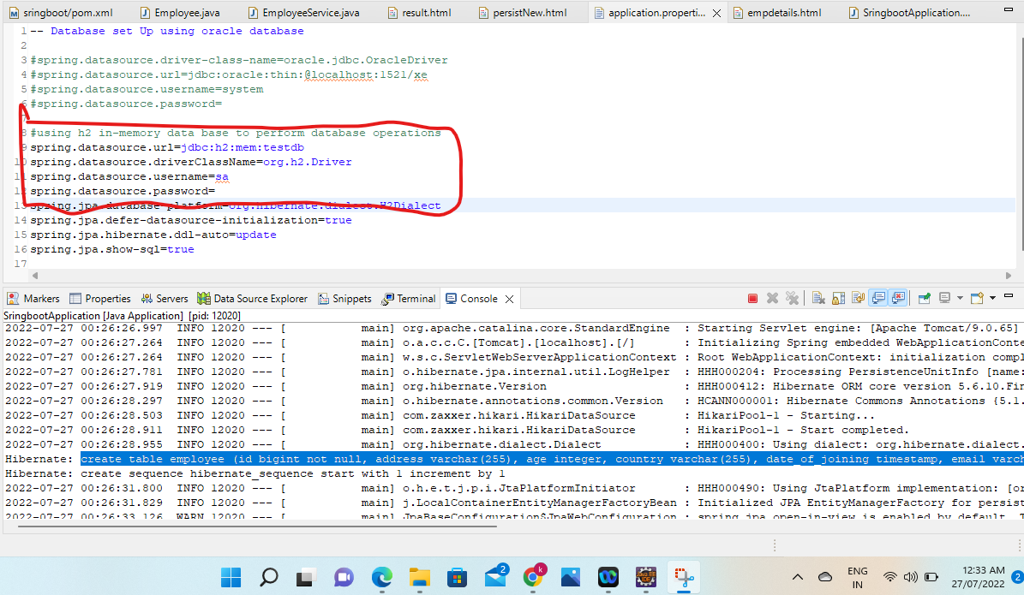

Https Request after spring boot getting started

http://localhost:8080/home

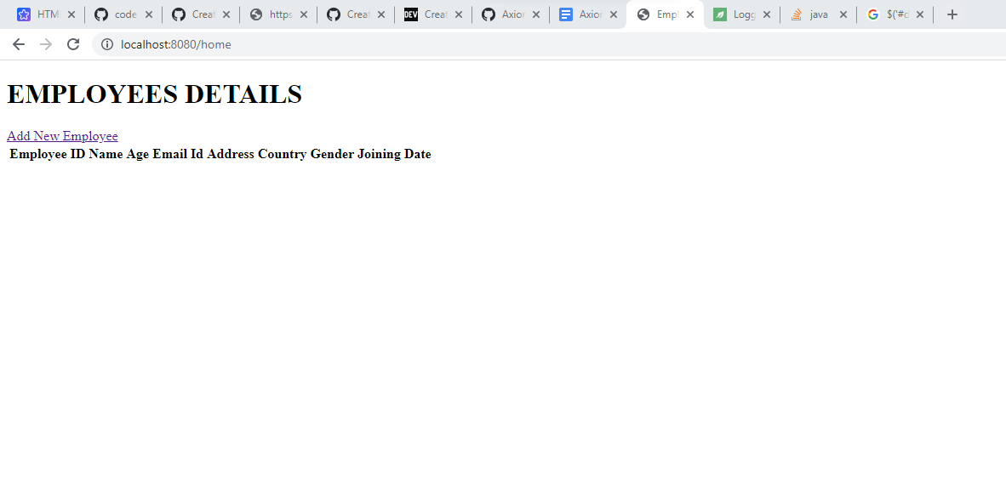

Click on Add New Employee Link

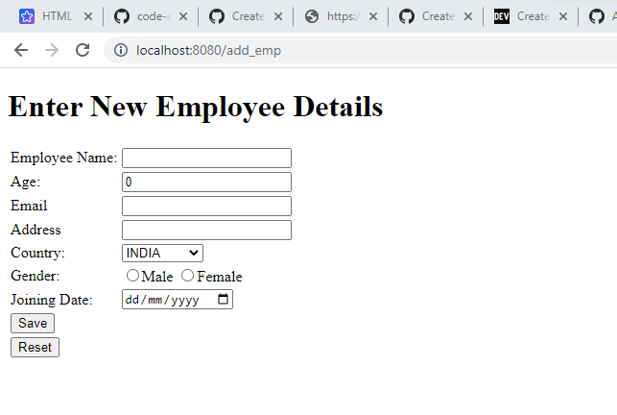

Enter all the employee details and click on save to navigate “home” page to see all the employee details which are getting pulled from the in-memory database

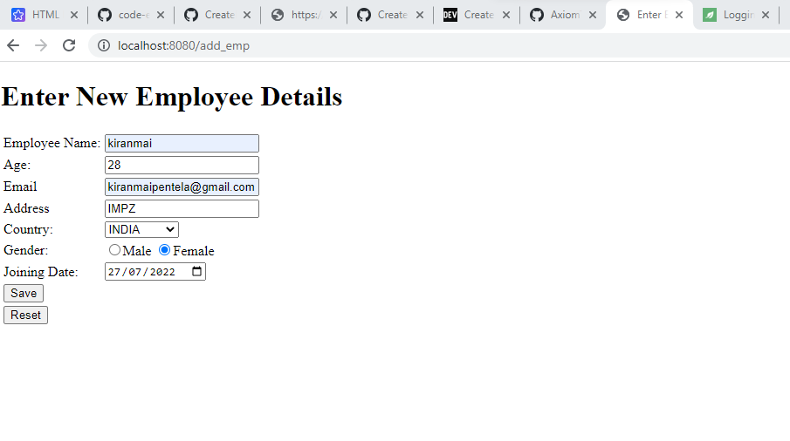

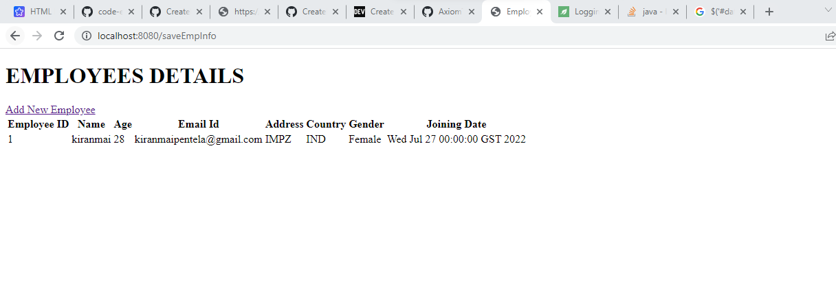

Again click on the add new employee to insert another employee data

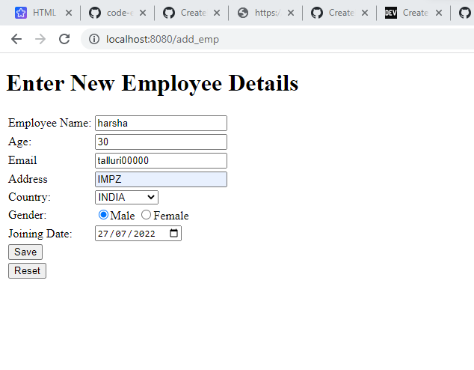

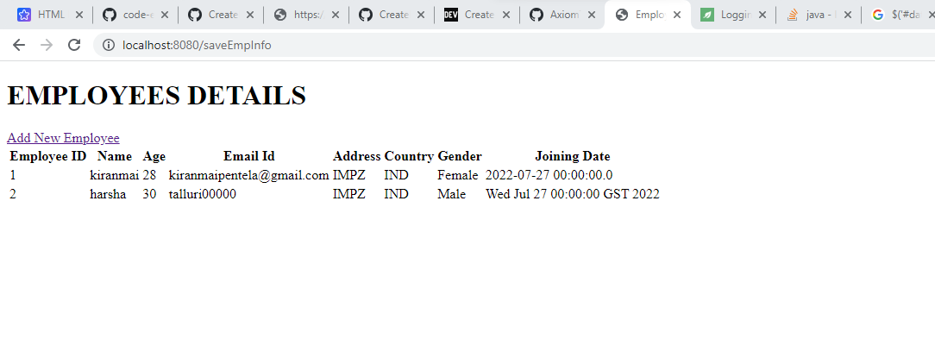

Now enter emp details and click on rest to clear off the data

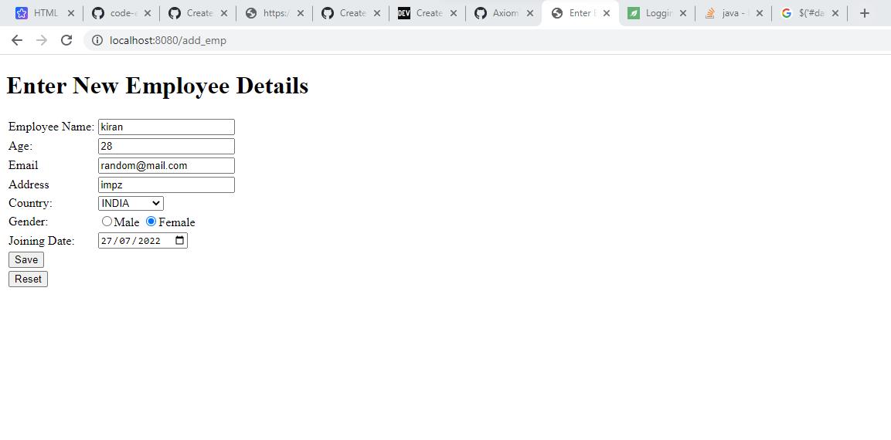

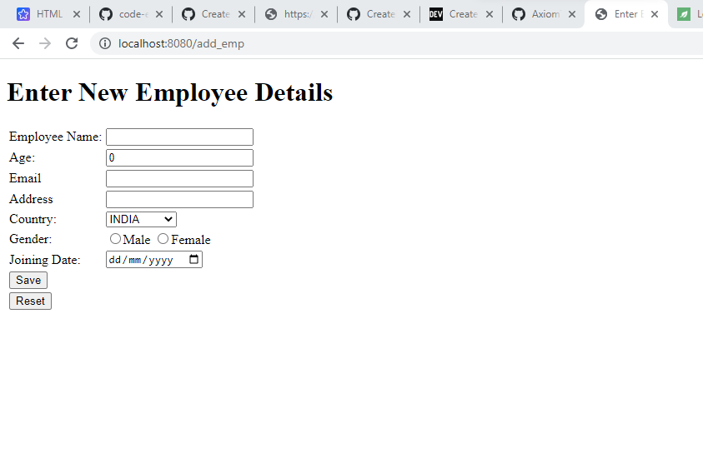

To Navigate Home page if you dont want to insert any record

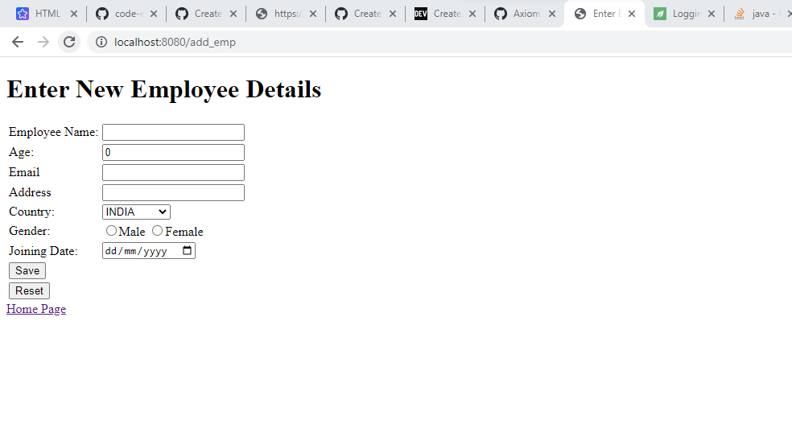

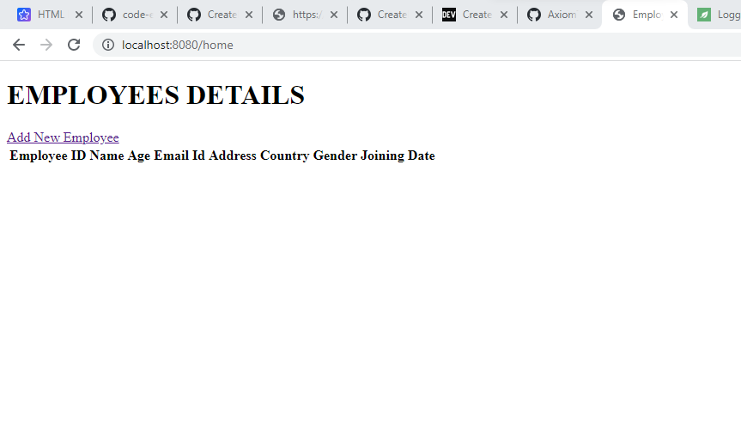

Source Code is available in below link